SOLIDWORKS-Solid Edge-Lantek conversion table:
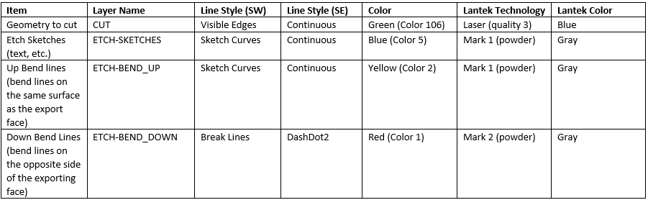
Solid Edge DXF options:
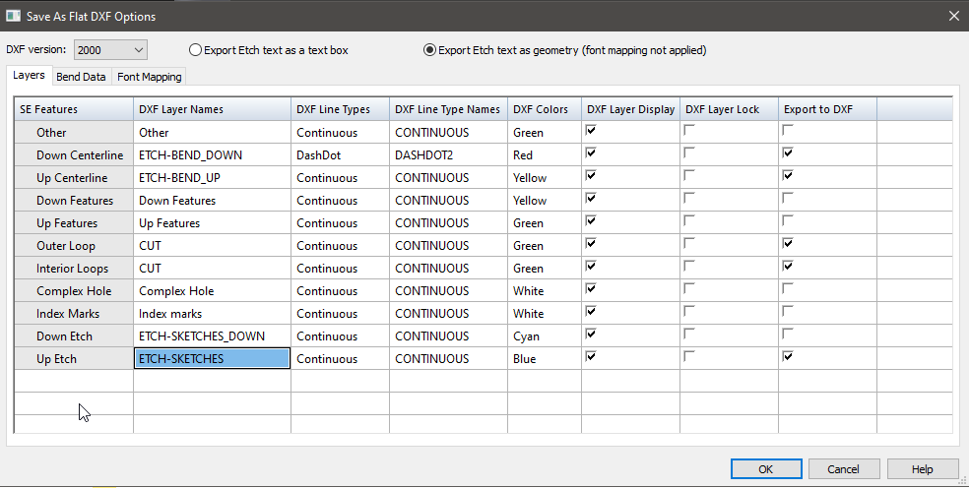
SOLIDWORKS DXF options:
